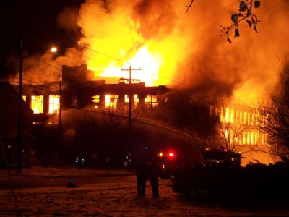
Continuity of Operations Tabletop Exercise
Participant Feedback Form

Please help us document today’s important findings. Record your answers in the spaces provided and leave this form with the facilitator before exiting.

- Overall, what are some strengths regarding our ability to prioritize and maintain essential functions during an emergency?
_________________________________________________________________________________________________________________________________________________________________________________________________________________________________

- What shortfalls or planning gaps exist in the following areas:
  - COOP Plan activation __________________________________________________________________________________________________________________________________________
  - Communicating with employees
__________________________________________________________________________________________________________________________________________
  - Resuming essential functions & personnel
__________________________________________________________________________________________________________________________________________
  - Utilizing alternate facilities
__________________________________________________________________________________________________________________________________________
  - Establishing lines of succession/authority
__________________________________________________________________________________________________________________________________________
  - Communicating with the public
__________________________________________________________________________________________________________________________________________
  - Other
__________________________________________________________________________________________________________________________________________

- What recommendations do you have to improve our COOP planning efforts?
_________________________________________________________________________________________________________________________________________________________________________________________________________________________________

Thank you for your valued participation.

