Reservations: 1800-322-3772

Or
www.stateparks.utah.gov

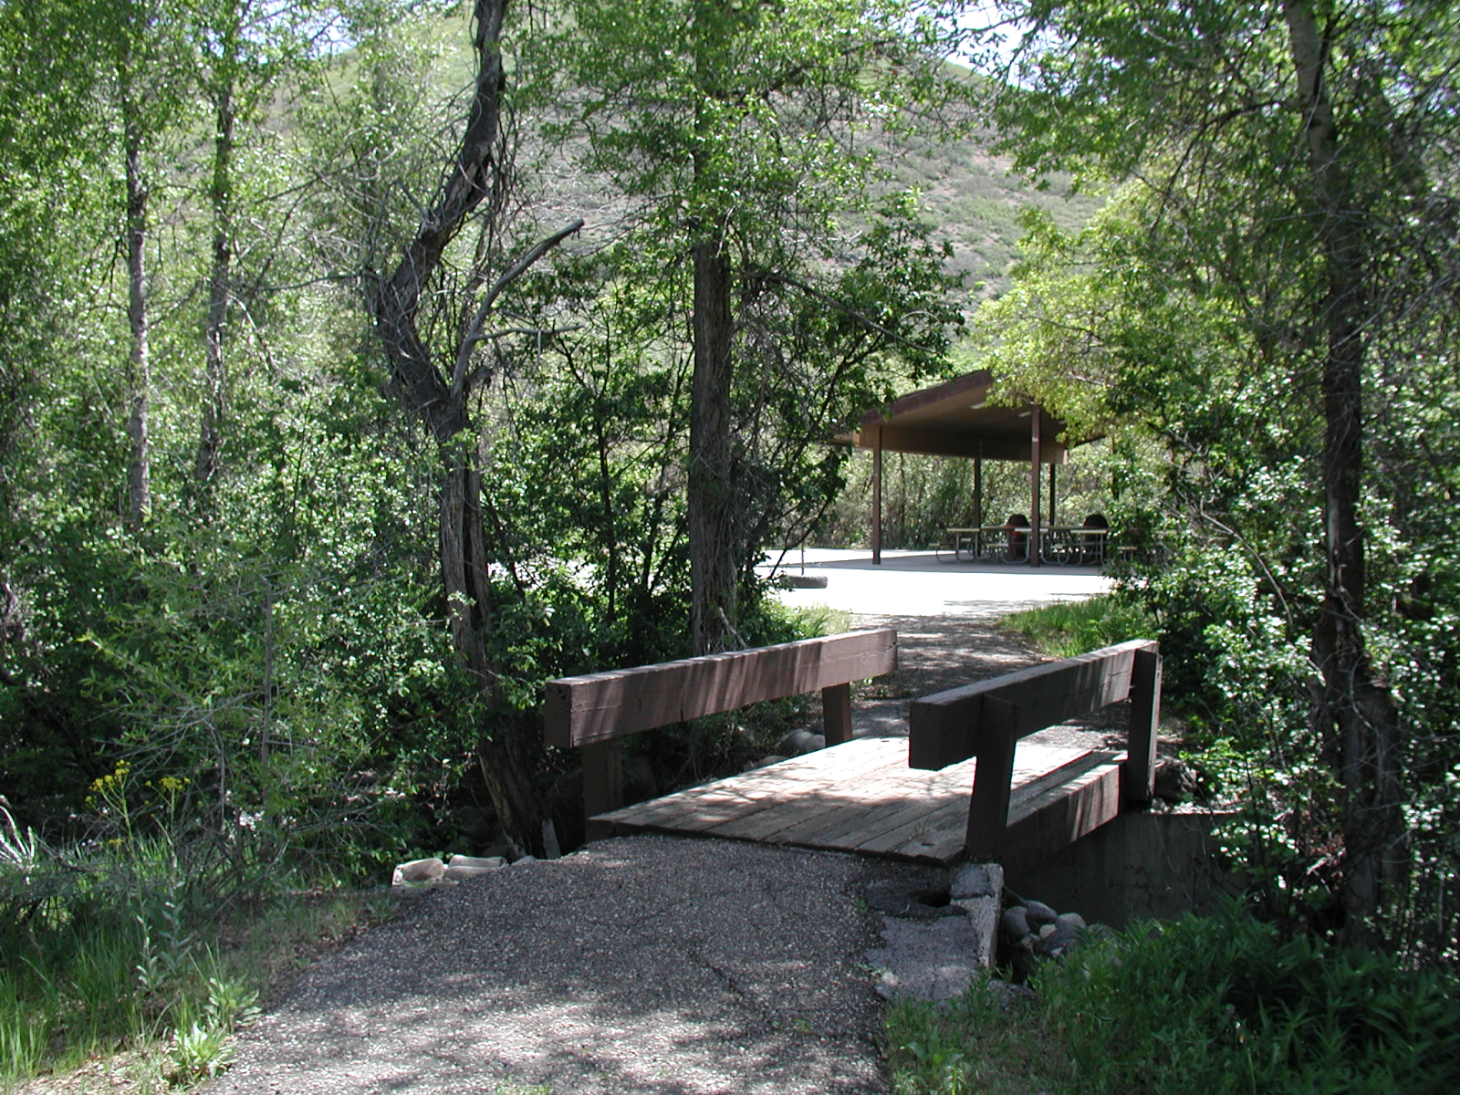

Springer Hollow
Overnight Group Area

Available for groups or families up to 50 people.

Right next to Wasatch Mountain Golf Course.

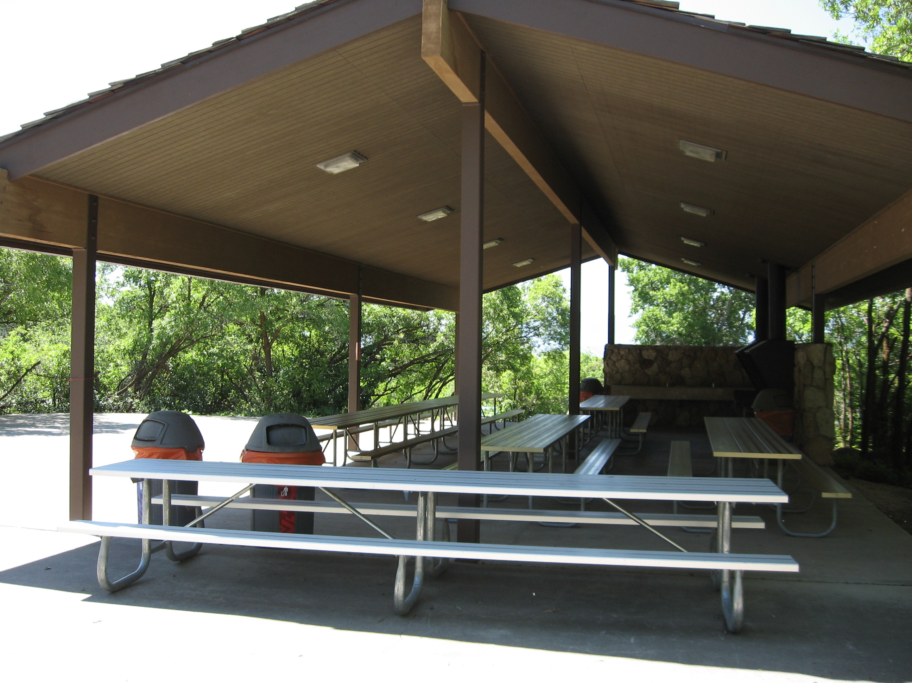
Amenities:

- Tables
- Grills
- Electricity
- Cold water sinks
- Volleyball standards
- Horseshoe pits
- Fire ring
- Access to hiking
- 8 tent pads
There is parking for 15 vehicles.

Restrooms and showers nearby

No lawn area. This pavilion is within an enclosed, wooded area.
Tents only! Trailers are not allowed.

Cancellations and Refunds:
If you must cancel a reservation, call 1-800-322-3770. Cancellations must be made more than 14 days in advance of arrival to receive a full refund minus the reservation fee.

Fee: $100/day
Reservation Fee: $10.25
(non-refundable)

