Lunch and Learn Series
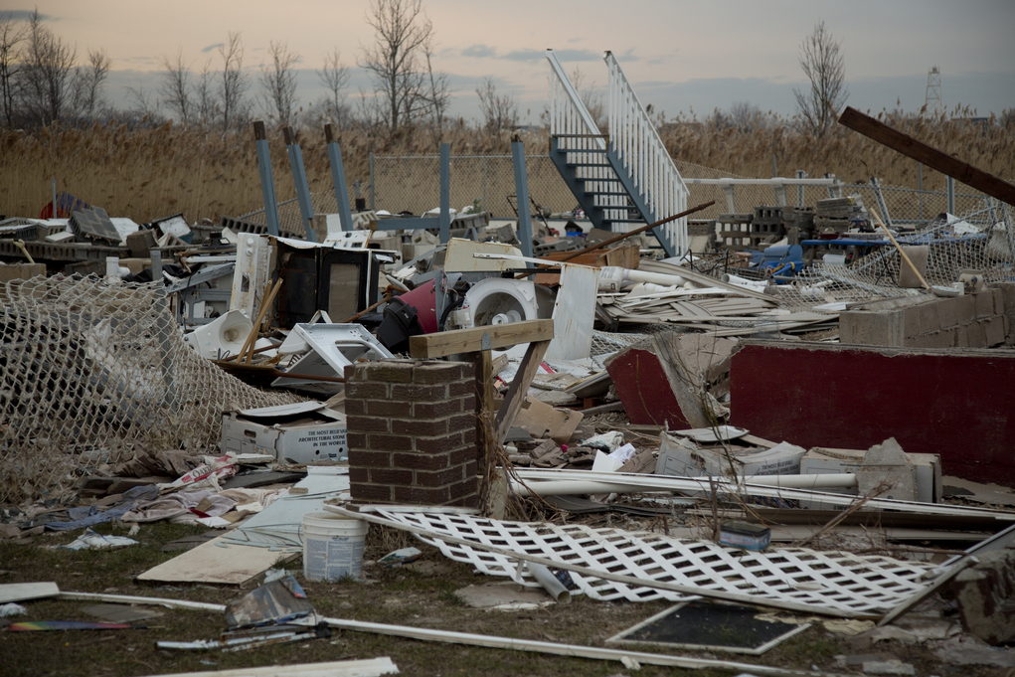
How the Media Influences Our Thinking During Times of Crisis
Join award winning KSL reporter, Alex Cabrero, for a discussion about how the media influences the public’s perceptions when disasters strike.
Wednesday, March 29, 2017
11:00am – 1:00pm
ICDP: 325 8th Ave and “C” St, at LDS Hospital, 3rd Flr North
Class is free and Complimentary Box Lunch will be provided
Register at https://wwww.utah.train.org Course# 1068417
ABOUT THE ICDP
. . . . . . . . . . . . . . . . . . . . .

The Intermountain Center for Disaster Preparedness (ICDP) promotes integrative and collaborative all-hazards prevention, preparedness, response, recovery, and mitigation for the whole community through training and education; exercises; planning and assessments; and research. The whole community includes first responders, healthcare systems, nonprofit groups, schools and academia, the media, and all levels of government.

