FOR IMMEDIATE RELEASE

Media Contacts
Utah Geological Survey U.S. Geological Survey
Mark Milligan Jennifer LaVista
801-537-3326 303-202-4764
MarkMilligan@utah.gov jlavista@usgs.gov

New Report Forecasts the High Likelihood of Damaging Earthquakes
During the Lifetime of Many Utah Residents

Salt Lake City (April 18, 2016) — In the first comprehensive study of its kind for Utah, Earthquake Probabilities for the Wasatch Front Region in Utah, Idaho, and Wyoming forecasts the chances for damaging earthquakes in the Wasatch Front region. In the next 50 years there is a 43 percent chance, or nearly 1-out-of-2 odds, of at least one large earthquake of magnitude 6.75 or greater. For a moderate quake of magnitude 5 or greater the probability is 93 percent, or greater than 9-out-of-10 odds.
“Considering that the average age of Utah’s citizens is the youngest in the nation at about 29 years, there is a realistic chance that many current residents will experience a large earthquake in their lifetime,” says Ivan Wong, Principal Seismologist at Lettis Consultants International and lead author of the report.
The soon-to-be-released report is a collaboration of 14 scientists from academia, federal and state agencies, and private industry. The results underscore the importance of being prepared for damaging earthquakes in Utah.
Scientists cannot predict exactly when and where an earthquake will occur and thus rely on forecasts to convey the chances of future quakes. Similar to weather forecasts, earthquake forecasts give the probability that an earthquake of a specific magnitude will occur within a specific region within a particular time period.
The new report forecasts quakes within the Wasatch Front region, where nearly 80 percent of Utah’s population resides. The report covers time periods significant to an individual’s lifetime of 30, 50, and 100 years, and addresses earthquakes strong enough to potentially cause significant to catastrophic damage, magnitude 5 up to about 7.5. Even a moderate quake of magnitude 5 can cause considerable damage such as fallen plaster and broken chimneys, but a large quake of magnitude 6.75 or greater can cause catastrophic damage, including collapse, to structures such as unreinforced masonry (brick) buildings.
The well-known Wasatch fault is the most likely fault in the region to generate a large earthquake, having an 18 percent probability of at least one earthquake of magnitude 6.75 or greater in the next 50 years. However, the new report highlights many other mapped and even unmapped faults that contribute to the chances of an earthquake. When considered together, these many faults significantly increase the regional probabilities of an earthquake.

Utah residents have several resources available to help them with earthquake preparedness. The annual Great Utah Shakeout is Utah’s largest earthquake drill. Nearly 1 million people are expected to participate in this year’s drill on April 21st. For more information and to sign up see shakeout.org/utah.
Be Ready Utah, the state’s emergency preparedness program run by the Division of Emergency Management, shares information about earthquakes and other hazards on its website, BeReadyUtah.gov, and everywhere on social media.
The Utah Seismic Safety Commission publication Putting Down Roots in Earthquake Country—Your Handbook for Earthquakes in Utah gives information on earthquake hazards and preparedness, and is available at www.utah.gov/beready/documents/roots_earthquake_low.pdf.
The Earthquake and Engineering Research Institute, Utah Chapter, recently published a report describing hazards and loss estimates from a magnitude 7 earthquake in the Salt Lake City area. Scenario for a Magnitude 7.0 Earthquake on the Wasatch Fault–Salt Lake City Segment—Hazards and Loss Estimates is available at dem.utah.gov/wp-content/uploads/sites/18/2015/03/RS1058_EERI_SLC_EQ_Scenario.pdf.
Also, EERI Utah is conducting a Utah Earthquake Resiliency Workshop (utah.eeri.org/?p=441) on April 27 at the Viridian Event Center in West Jordan. This workshop will highlight topics related to improving community recovery after a damaging earthquake. The workshop will feature nationally known experts as keynote speakers with significant background in the field of resilience.
_____________________________________________________________________________________________________________________

Utah Geological Survey Miscellaneous Publication 16-3, Earthquake Probabilities for the Wasatch Front Region in Utah, Idaho, and Wyoming, is expected to be released in early May and will be available for purchase from the Utah Department of Natural Resources Map and Bookstore, 1-888-UTAHMAP, www.mapstore.utah.gov. A PDF will be viewable on the UGS website at geology.utah.gov. This research was funded by grants from the USGS National Earthquake Hazards Reduction Program with additional support from the Utah Geological Survey and URS Corporation. The Utah Geological Survey, a division of the Utah Department of Natural Resources, provides timely scientific information about Utah’s geologic environment, resources, and hazards.
The U.S. Geological Survey has produced a non-technical summary of the full earthquake probabilities report. USGS Fact Sheet 2016-3019 is available at pubs.er.usgs.gov/publication/fs20163019.
For more information about the Wasatch Front earthquake forecast, please contact:
Ivan Wong
Lettis Consultants International, Inc.
(925) 482-0360
wong@lettisci.com

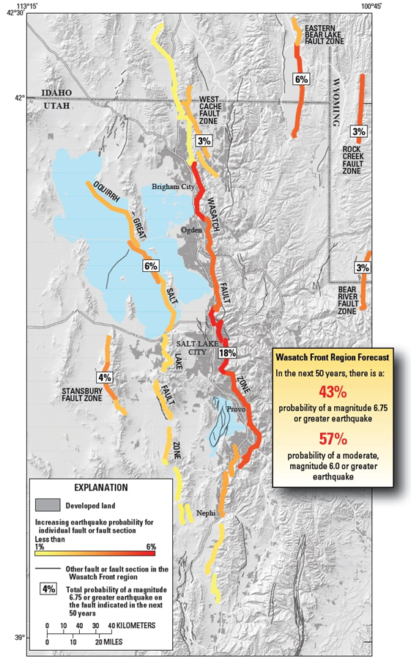
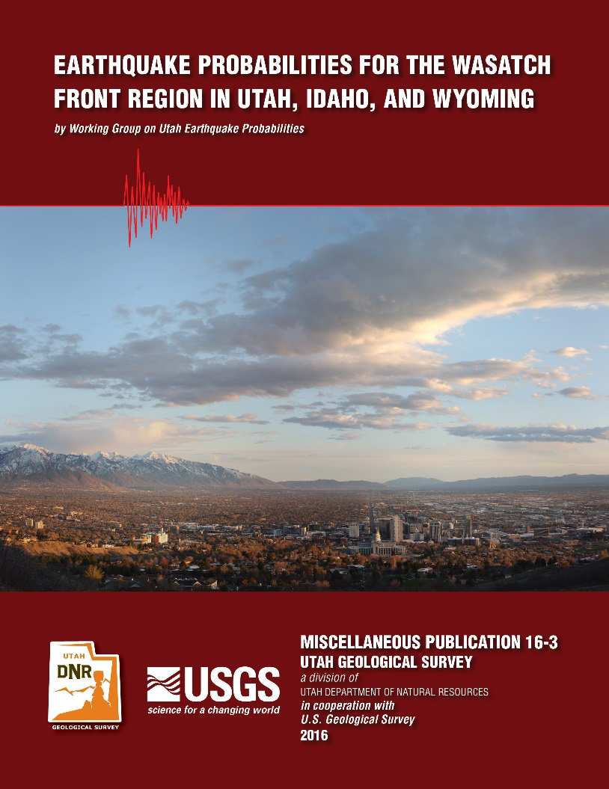

Map from USGS Fact Sheet 2016-3019

# # #

