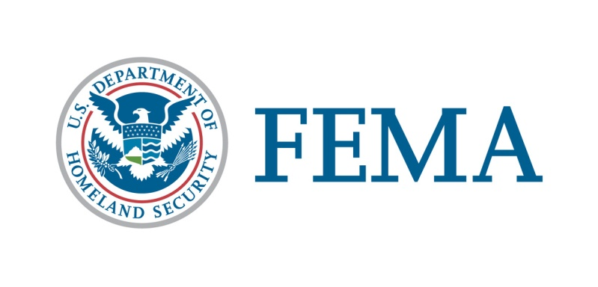

##### Congressional Affairs Division

202-646-4500

**State of Utah**

**Federal Disaster Declaration Fact Sheet**

**April 21, 2017**

Today, April 21, 2017, President Trump issued a Major Disaster Declaration for the State of Utah triggering the release of Federal funds to help communities recover from the Severe Winter Storms and Flooding that occurred February 7-27, 2017.  Details of the disaster declaration and assistance programs are as follows:

Declaration Number:                      FEMA-4311-DR

Incident:                                          Severe Winter Storms and Flooding

Incident Period:                               February 7-27, 2017

Federal Coordinating Officer:          Nancy M. Casper

                                                          National FCO Program

Public Assistance (PA):                   (Assistance for emergency work and the repair or replacement of disaster-damaged facilities):

PA-Designated Areas:                     Box Elder and Cache Counties.

Hazard Mitigation (HM):                 (Assistance for actions taken to prevent or reduce long term risk to life and property from natural hazards):

HM-Designated Areas:                     All areas in the State of Utah are eligible for assistance under the Hazard Mitigation Grant Program.

OTHER:                                            Additional designations may be made at a later date if requested by the State and warranted by the results of further damage assessments.

                                                                                                      ###