Fall 2017
To ULCT Members:

In 2016 and 2013 changes were made to the Land Use development and Management Act regarding subdivisions. We are providing this summary as a reminder to bring your codes and practices in compliance with the statute.

Summary:
SB124 was a ULCT Land Use Task Force Bill passed in 2016 that was vetted by over 60 public and private stakeholders in the land development process.

The Land Use Task Force focused on a variety of land use topics, including:
1) subdivision for utilities; 2) illegal exactions; 3) security for public infrastructure; 4) modifying common area on a plat and 5) easing state imposed site plan restrictions in first class counties.

Subdivision for Utilities:
Lines 390-391 address how to allow for the subdivision of a large parcel to create a legal parcel that is so small, it would be undevelopable for anything other than its intended use: a small utility substation or use. Lines 390-91 allow a jurisdiction to exempt a subdivision of land from subdivision standards to accommodate siting public utility infrastructure.

Illegal Exactions:
Lines 415-421 compliment state law provisions that prohibit unconstitutional exactions in the subdivision context. This language limits the signature requirements on subdivision plats to public entities, utilities, the subdividing landowners, and their agents.

Lines 436-4·46 instruct a surveyor to consult with underground utilities to assure the accuracy of a surveyed plat prior to final plat approval. Existing law had required the surveyor to obtain approval from underground utilities, which included private canal companies.

Security for Public Infrastructure:
Lines 150-158 refine the definitions of what we know more commonly as subdivision improvement bonds and warranties.

Lines 173-180 define what an "infrastructure improvement" is in order to limit the extent and cost of subdivision improvement bonds and guaranties. Some jurisdictions have been using infrastructure bonds to assure construction of private amenities. They should use development agreements and phasing plans for those items, rather than infrastructure bonds.

Lines 464-4·67 are technical changes.

Lines 4•8 6 -8 7 have been inserted to confirm that an applicant and a local government can and do enter into enforceable phasing plans and development agreements, which will control when building permits will be issued. Often, with large developments, a developer promises to construct certain amenities after it has the right to construct some homes, but before it has the right to build additional homes or structures. These amenities may not qualify to be included in a public infrastructure bond and this bill adds clarity to what can and cannot be include in infrastructure bonds. However, to assure completion of important private improvements, the local government and the developer may enter into an agreement that is enforceable independent of the infrastructure bond.

Common Area in Plats:
Lines 508-515 describe that common area on a plat can be modified in size and location with local approval and the consent of 75% of an HOA.

Each of these changes are also made to the County's Land Use Act in Chapter 17.27a One change is unique to Counties:
First Class Counties Site Plan Restrictions:
Line 882 allows a County of the first class to regulate landscaping and re-vegetati on of a development lot. That authority had been removed for all counties and should be restored for an urba nized County.

Typical Subdivision Plat Recording Process

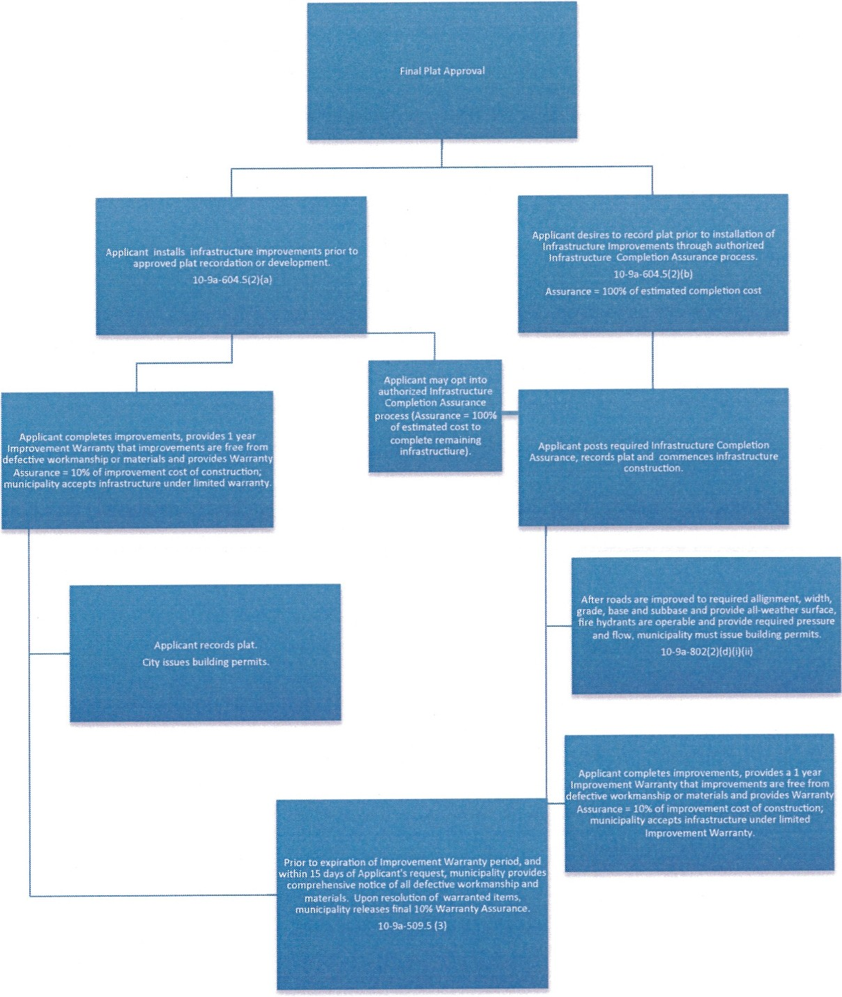

Effective 5/12/2015
10-9a-103. Definitions. As used in this chapter:

- "Development activity" means:
  - any construction or expansion of a building, struct ure, or use that creates additional demand and need for public facilities;
  - any change in use of a building or structure that creates additional demand and need for public facilities; or
  - any change in the use of/and that creates additional demand and need for public facilities.
- "Improvement completion assurance" means a surety bond, letter of credit, financial institution bond, cash, assignment of right s, lien, or other equivalent security required by a municipality to guaranty the proper completion of landscaping or an infrastructure improvement required as a condition precedent to:
  - recording a subdivision plat; or
  - development of a commercial, industrial, mixed use, or multifamily project.
- "Improvement warranty" means an applicant's unconditional warranty that the applicant's installed and accepted landscaping or infrastructure improvement:
  - complies with the municipality's written standards for design, m at erials, and workmanship; and
  - will not fail in any material respect, as a result of poor workmanship or materials, within the improvement warranty period.
- "Improvement warranty period" means a period:
  - no later than one year after a municipality's acceptance of required landscaping ; or
  - no later than one year after a municipality's acceptance of required infrastructure, unlessthe municipalit y:
{i) determines for good cause that a one-year period would be inadequate to prote ct the public health , safety, and welfare; and
    - has substantial evidence, on record:
      - of prior poor performance by the applicant; or
      - that the are a upon which the infrastructure will be constructed contains suspect soil and the municipality has not otherwise required the applicant to mitigate the suspect soil.
- "Infrastructure improvement" means permanent infr ast ruct ur e that an applicant must install:
  - pursuant to published installation and inspection specifications for public improvements; and
  - as a condition of:
- recording a subdivision plat ; or
- development of a commercial, industrial, mixed use, condominium, or multifamily project.

- "Land use ordinance" means a plannin g, zoning, development, or subdivision ordinance of the municipality, but does not include the general plan.
- "land use permit" means a permit issued by a land use authority.

(38) "Plat" means a map or other graphical representation of lands being laid out an d prepared in accordance with Section 10 -9a-603, 17-23-17, or 57-8-13.

10-9a-509.S. Review for application completeness -- Substantive application review -- Reasonable diligence required for determination of whether improvements or warranty work meets standards·· Money damages claim prohibited.
- (a) With reasonable diligence, each land use authority shall determine whether the installation of required subdivision improvements or the performance of warranty work meets the municipality's adopted standards.
- (i) An applicant may in writing request the land use authority to accept or reject the applicant's installation of required subdivision improvements or performance of warranty worl<.
(ii) The land use authority shall accept or reiect subdivision improvements within 15 days after receiving an applicant's written request under Subsection (3){b)(i), or as soon as practicable after that 15-day period if inspection of the subdivision improvements is impeded by winter weather conditions.
{iii) The land use authority shall accept or reiect the performance of warranty work within 45 days after receiving an applicant's written request under Subsection (3)(b)(i), or as soon as practicable after that 45-day period if inspection of the warranty work is impeded by winter
weather conditions.
- If a land use authority determines that the installation of required subdivision improvements or
the performance of warranty work does not meet the municipality's adopted standards, the land use authority shall comprehensively and with specificity list the reasons for its determination,
- Subject to Section 10-9a-509, nothing in this section and no action or inaction of the land use authority relieves an applicant's duty to comply with all applicable substantive ordinances and regulations.

Effective 5/12/2015
10-9a-603. Plat required when land is subdivided -- Approval of plat-· Owner acknowledgment, surveyor certification, and underground utility facility owner verification of plat·· Recording plat .

(2) (a) Subject to Subsections (3), (4), and (5), if the plat conforms to the municipality's ordinances and this part and has been approved by the culina ry water aut hority, the sanitary sewer autho rity, and the local health department, as defined in Section 26A-1-J.02, if the local health department and the municipality consider the local health department's approval necessary, the municipality shall approve the plat.
(5) (a) After the plat has been acknowledged, certified, and approved, the owner of the land shall, within t he time period designated by ordinance, record the plat in the county recorder's office in the county in which the lands platted and laid out are situated.

Effective 5/12/2015
10-9a-604.5. Subdivision plat recording or development activity before required infrastructure is completed -- Infrastructure completion assurance- Infrastructure warranty,

- A land use authority shall establish obiective inspection standards for acceptance ofa required landscaping or infrastructure improvement.
- (a) A land use authority shall require an applicant to complete a required landscaping or infrastructure Improvement prior to any plat recordation or development activity.
f.h1 Subsection (lJ(a} does not apply If:
ill upon the applicant's request, the land use authority has authorized the applicant to post an

2013 Infrastructure "Bond" Laws – A refresher
Remember: the 2013 infrastructure "bond" laws. Under these laws there are two different "sureties" to protect the public from shoddy subdividers: one "surety" is to make certain the infrastructure is actually built; a separate surety is a "warranty'' that can and should be used to guard against "latent" defects in materials and workmanship.

Many cities had combined the two concepts into a single "bond" and are still using that practice today. Each jurisdiction should review the new law with its staff/project engineers to be certain its "bond" practice includes these two concepts and meets the letter of the new law.

In a nutshell:
- Surety #1. A City should require an infrastructure completion bond, but may do so only if a subdivider/developer asks to record a plat prior to building required infrastructure. If the subdivider wishes to complete the required infrastructure before recording the approved plat, the city may not require an infrastructure completion bond. The surety for the city in this instance is to hold the plat until the infrastructure is complete, and then allow the subdivider to record it.

  - This first "surety" is now referred to in the statute as an "improvement completion assurance".

  - It can be cash, a letter of credit, a traditional surety bond "or other security".

  - It is held by the city to construct the improvements if the subdivider fails to do so.

  - Surety #1 must be released upon the:

1. city's acceptance of the infrastructure; and if the City requests, the

11. subdivider's execution and delivery of the Improvement Warranty (aka Surety #2).

- Surety #2. Upon acceptance of the completed infrastructure, the city can/should require the subdivider provide an Improvement Warranty.

  - The Improvement Warranty has two parts:

i. A written contract obligating the subdivider to an unconditional warranty that the infrastructure:

- is built as the city has directed: it complies with the city's written standards for design, materials and workmanship; and it

- will not fail as a result of poor workmanship or materials; within

- one year

A "surety": a letter of credit, surety bond, cash or other security.

    - This "surety" is limited to requiring the subdivider to "post" 10% of tlze lesser of:

- the engineer's estimated cost of completion; or the
-subdivider's proven "actual" cost of completion; and

    - Must be released or called within a year*.

Practice Tips:

The big differences between past practice and the new law are threefold:

- The distinction between completion and warranty assurances;

- The one year warranty period (which cannot be extended in most instances); and

- Neither surety creates a maintenance obligation.

