Cabin Reservations can be made by calling:

1-800-322-3770

Or Online
www.stateparks.utah.gov

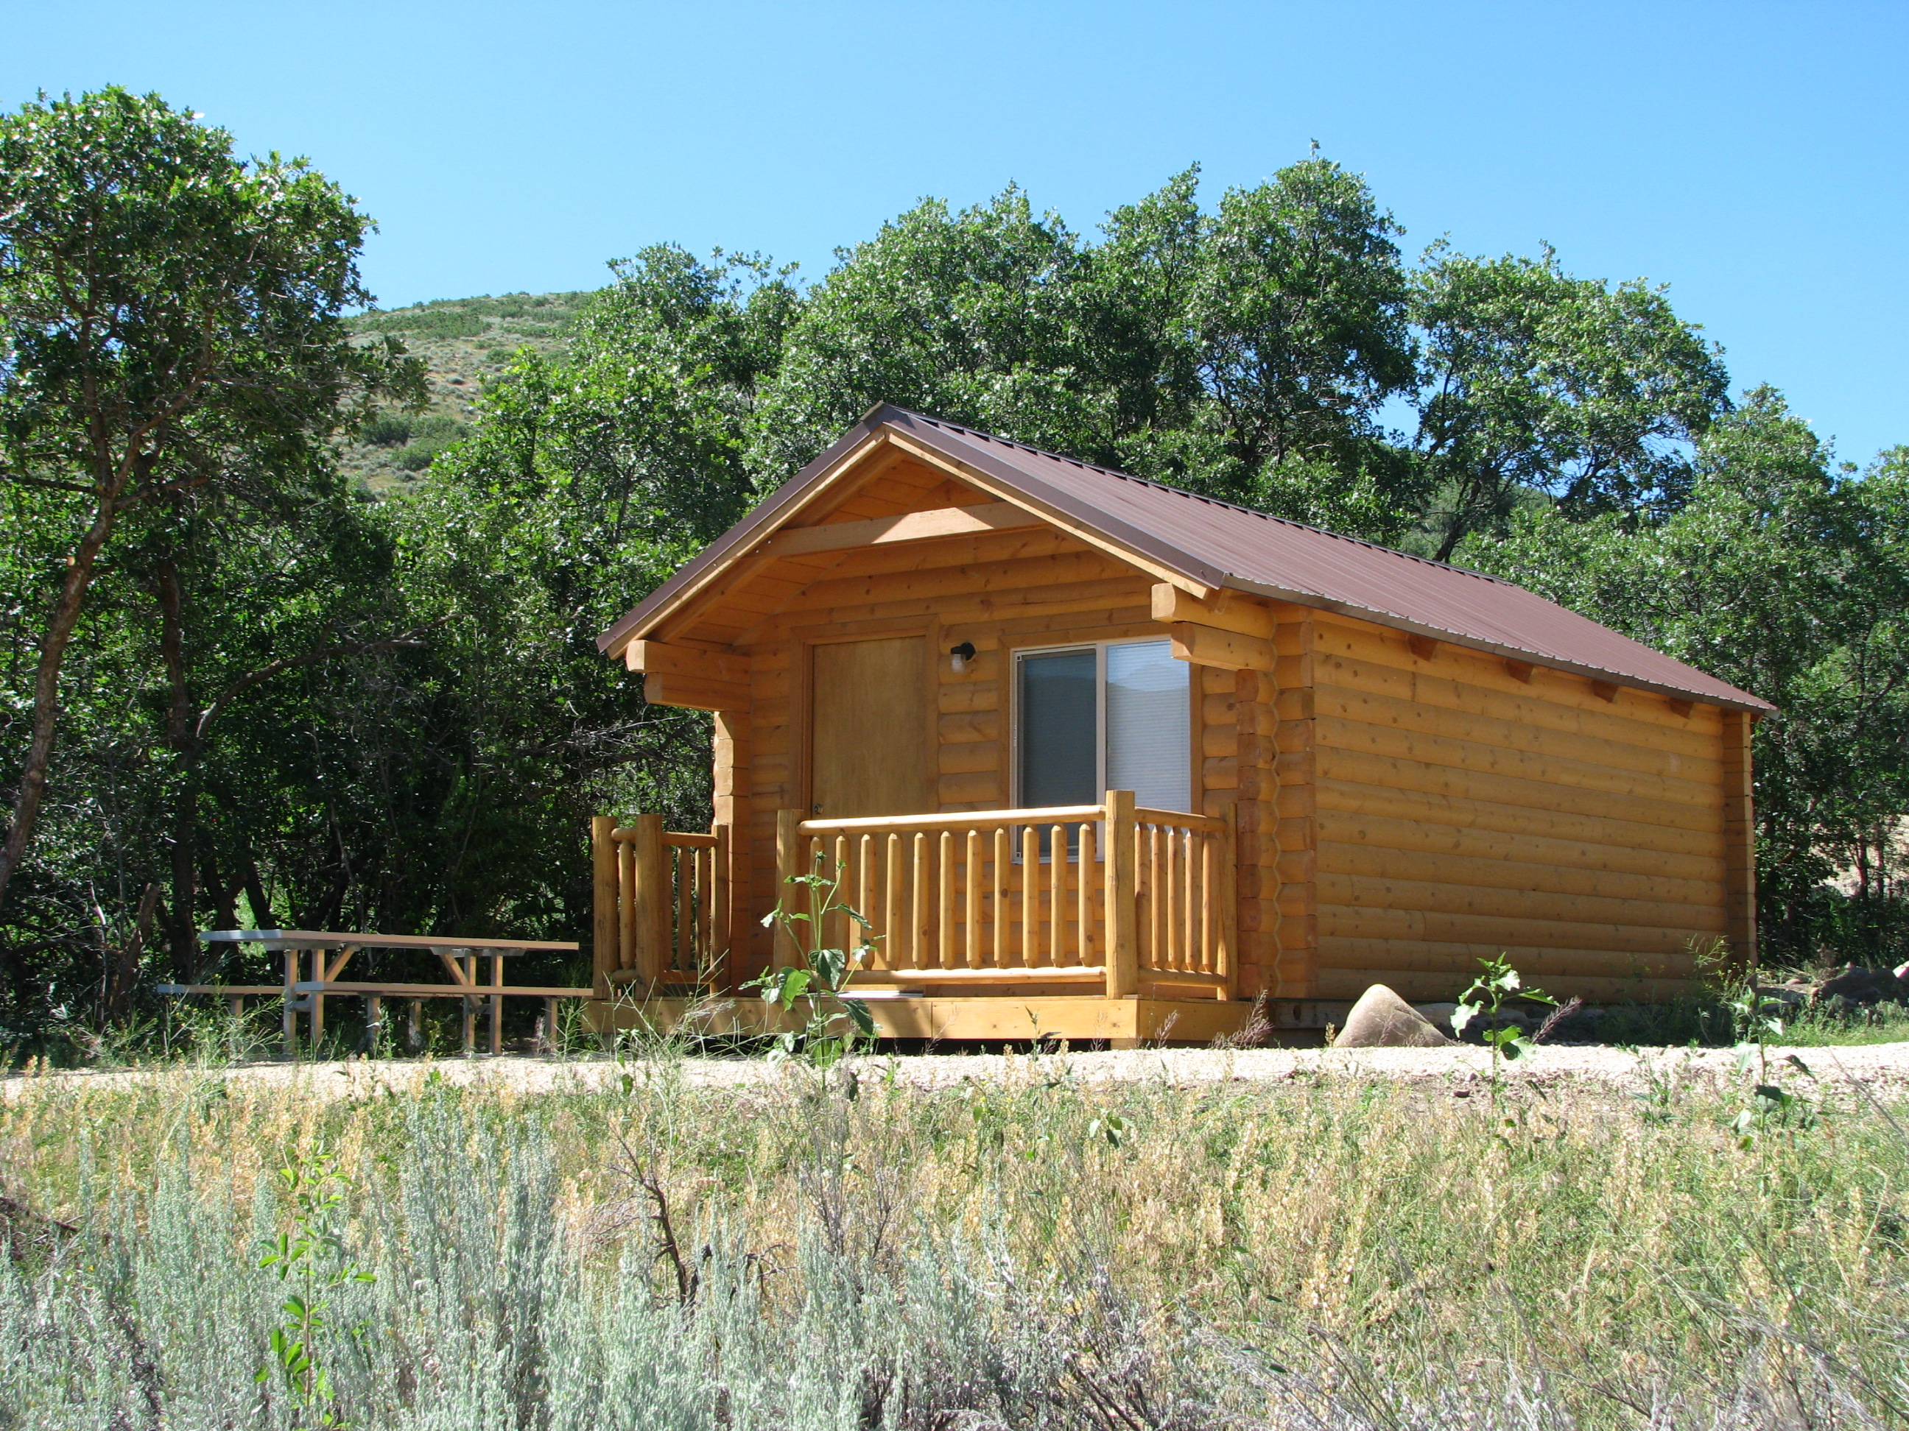
Eagles Nest and Falcons Ledge

Available for groups or families up to 6
No Smoking No Pets Permitted
Bring your own bedding
Check-in 3pm - Check-out 12pm

April - Oct: $70 Sun-Thurs
$85 Friday/Saturday/Holiday’s
November – March: $55 Sun -Thurs
$70 Friday/Saturday/Holiday’s
$100 cleaning deposit. (Refundable)
Reservation Fee: $8.00 (non-refundable)

Eagles Nest

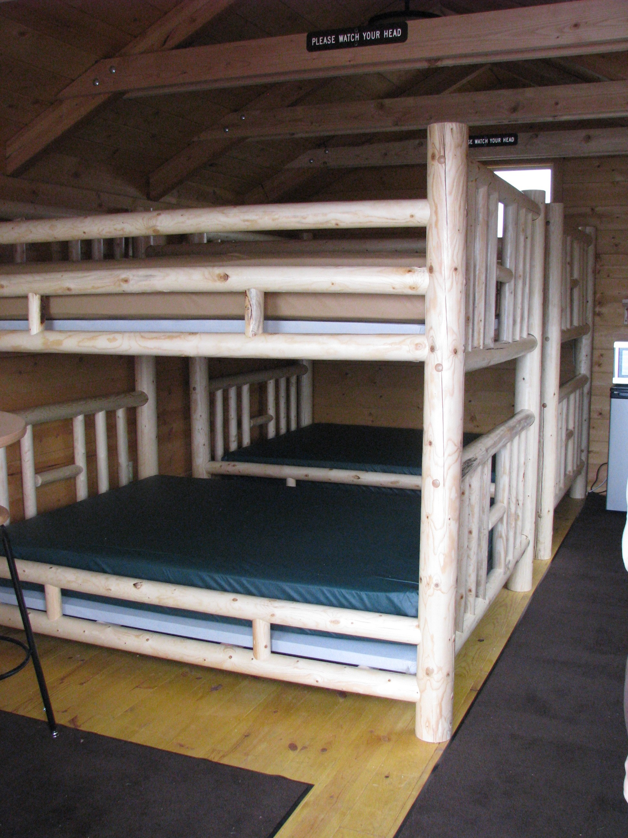
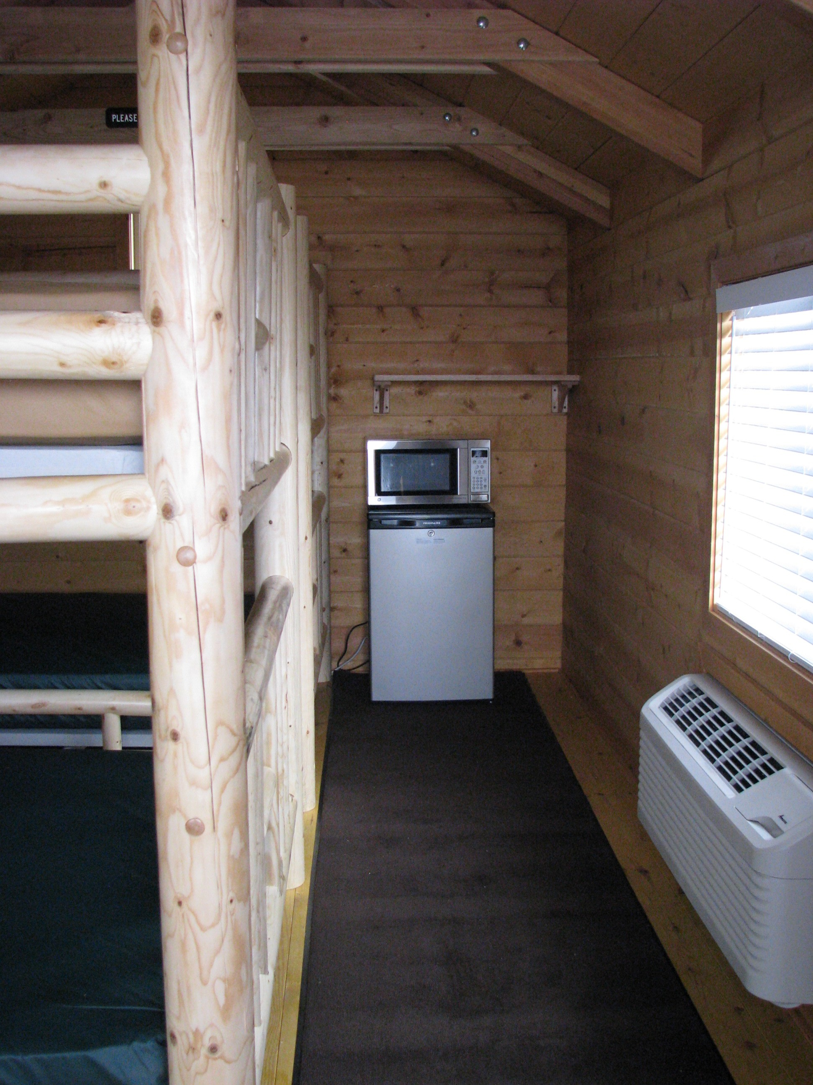
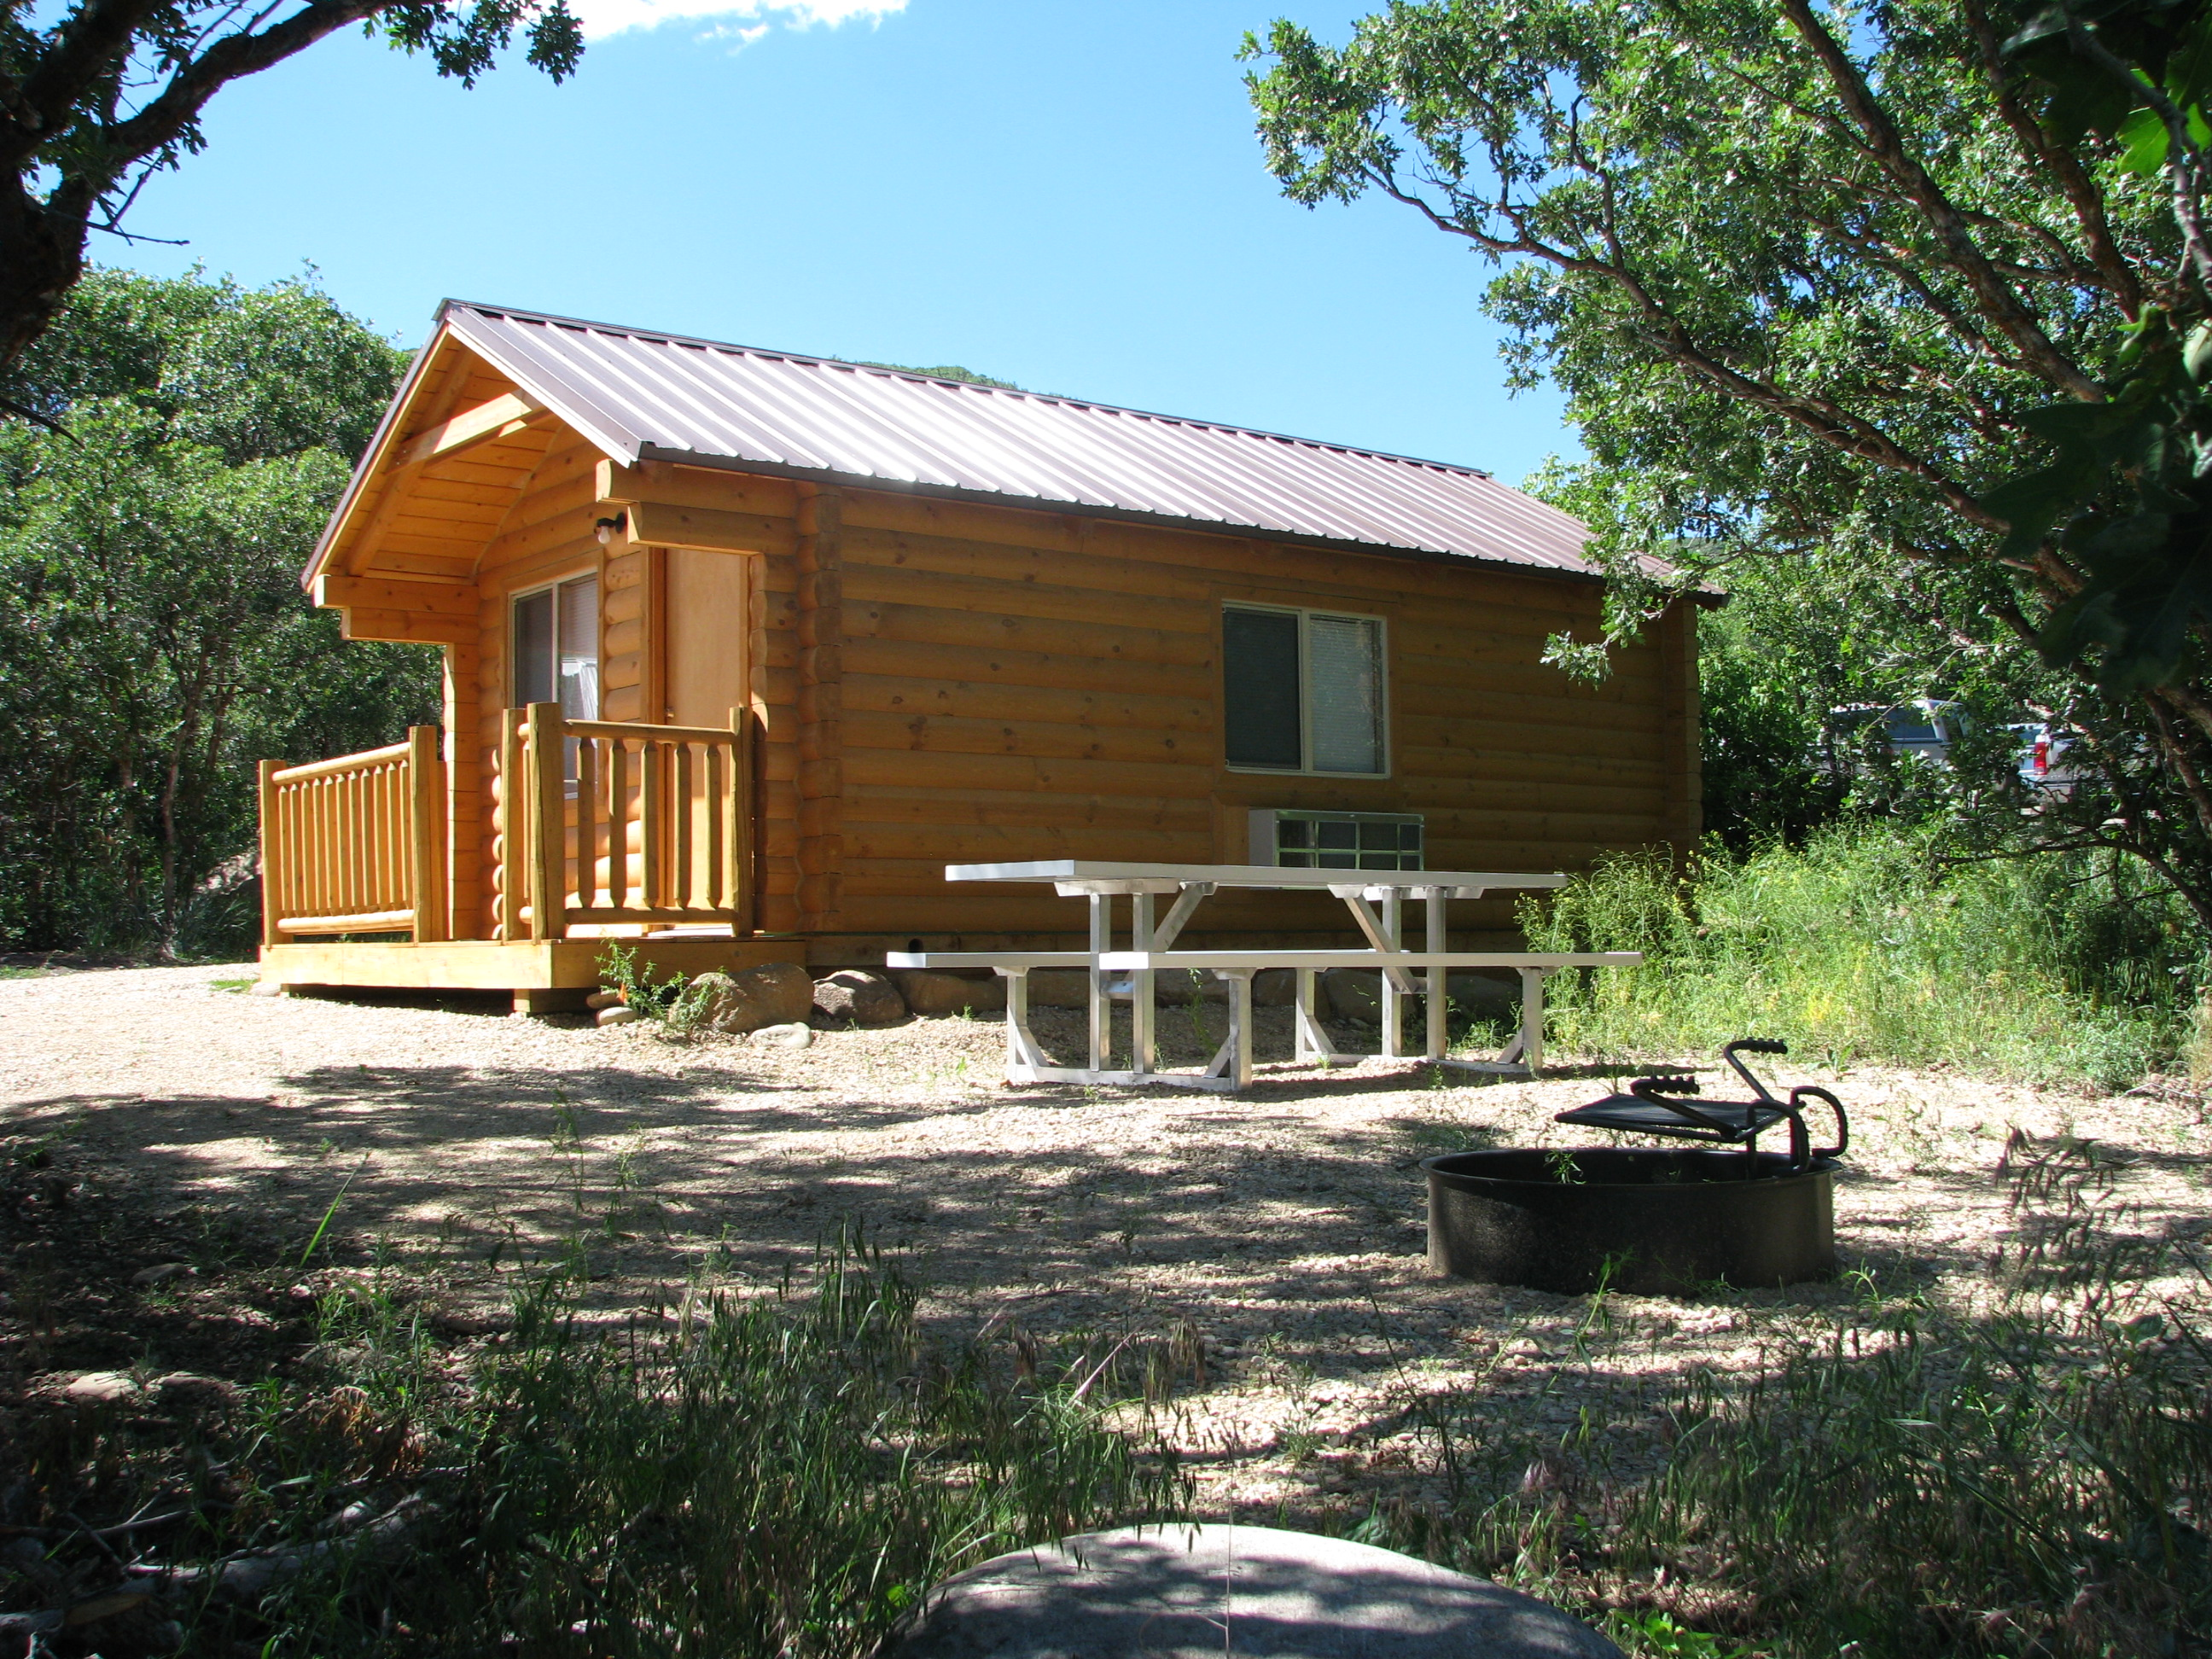
Cancellations and Refunds:
If you must cancel a reservation, call 1-800-322-3770. Cancellations must be made more than 14 days in advance of arrival to receive a full refund minus the reservation fee.

Amenities:

- 1 double bunk bed
- 1 sofa sleeper
- Electricity
- Table/2 chairs
- Mini fridge
- Microwave
- A/C - Heating
- Picnic table
- Fire ring with grill
- Water hydrant
- ADA (Falcons only)

Designated parking for one car. An extra vehicle may join for a fee. ($10)

Restrooms, across parking lot, showers in Cottonwood loop. (Showers are not available in winter.)
No lawn area. These cabins are located inside the Pine Creek Campground. Occupants must bring own bedding.
Falcons Ledge

